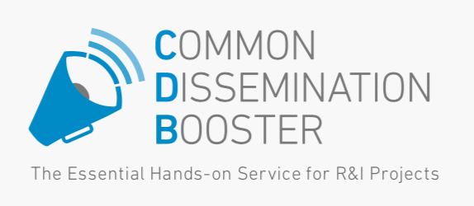

OpIRIS: Boosting the Project Resulting via CDB
Along with other 3 projects (VISCA, WEAM4i and LIFE IRRIMAN), OpIRIS project has been selected for the Common Dissemination Booster services.
Common Dissemination Booster
The Common Dissemination Booster (CDB) is a brand-new service from the European Commission available to all, ongoing or closed, European, National, Regional funded Research & Innovation (R&I) projects (H2020, FP7 or other). Applying was possible until 31/11/2017.
The booster encourages projects to come together to identify a common portfolio of results and shows them how best to disseminate to end-users, with an eye on exploitation opportunities.
Ago-food CDB
The participating projects have a common goal which is to provide innovative solutions (i.g. Decision support system and/or climate services) to improve the efficiency of the agro-food sector in Europe while limiting its impact on natural resources (water) and the use of energy.
The main end-users of this group of projects are: farmers, Irrigators associations association from different sectors including: wine-grapes, olives, rice, cereal, fruit trees, vegetables, etc.
In this booster, there are one active project (VISCA) and three finished projects (weam4I, OpIRIS and LIFE IRRIMAN) with promising results which are going to be boosted through this service.
Current projects in the CDB:
VISCA: Vineyards´ Integrated Smart Climate Application
Status: Ongoing
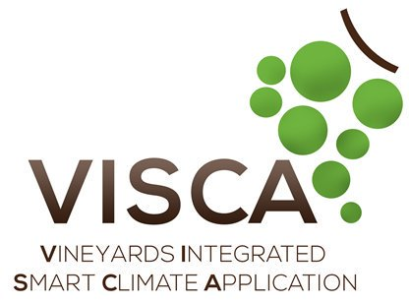
VISCA project aims to provide climate services for farmers to supply them with well-founded decisions for an appropriate crop planning (i.e. prunning, ripening, harvesting, fertilization, pest-control, etc.), with the ultimate goal of making the wine production industry resilient to effects due to climate change. The project is also going to evaluate the replicability potential in other relevant crops (olive, rice, etc) at international level. More information: link

WEAM4i: Water & Energy Advanced Management for Irrigation
Status: Finished (Results)
WEAM4i is a water-energy smart grid; an open ICT cloud platform that improves the efficiency of water use and reduce the costs of power irrigation systems. This platform integrates different information services and smart applications giving the possibility for the end-users to act interactively on the rational use of water and energy. More information: link

OpIRIS: Online Professional Irrigation Scheduling System
Status: Finished (Results)

OpIRIS is an online professional irrigation scheduling system formulated to progressively guide its visitors and sway them toward adopting water conservation practices and technologies following a win-win approach using sensor information to decide how much, how often and in what pattern to apply water. It is a low cost autonomous system, dealing with water, fertilizers and energy reduction in Hydroponic Greenhouses and Trees Orchards. More information: link

LIFE IRRIMAN: Implementation of efficient irrigation management for a sustainable agriculture
Status: Finished (Results)
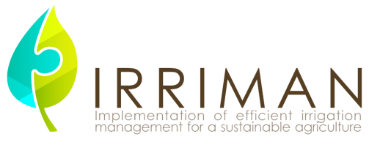
IRRIMAN Life + project aims to implement, demonstrate and disseminate a sustainable irrigation strategy based on deficit irrigation to promote its large-scale acceptance and use in Mediterranean agroecosystems crops, characterized by water scarcity, and without affecting quality standards required by export markets. More information: link

